ASSIGNMENT 1

PROGRAMMING FUNDAMENTALS

QUESTION 1

PAC:

GIVEN DATA | REQUIRED RESULTS
- CUSTOMER_ID  - AMOUNT_SPEND  - AMOUNT_LIMIT  - FOREIGN_COUNTRY  - COMMON_COUNTRIES  - NO_OF_TRANSACTIONS  - TRANSACTION_COUNT_HOUR | - MARK SUSPECIOUS ACTIVITY
PROCESSING REQUIRED | ALTERNATIVE SOLUTIONS
- Determine IF (AMOUNT_SPEND>AMOUNT_  LIMIT)  - Determine IF (FOREIGN_COUNTRY !=  COMMON_COUNTRIES)  - Determine IF (NO_OF_TRANSACTION >  TRANSACITON_COUNT_TIME)  - Then FLAG = TRUE | - Define all the values to be compared as constants in the program.  - Take input of all the values to be evaluated.  - Use mathematical formulas for formulating.  - Use comparing statements in conditional statements.

FLOWCHART: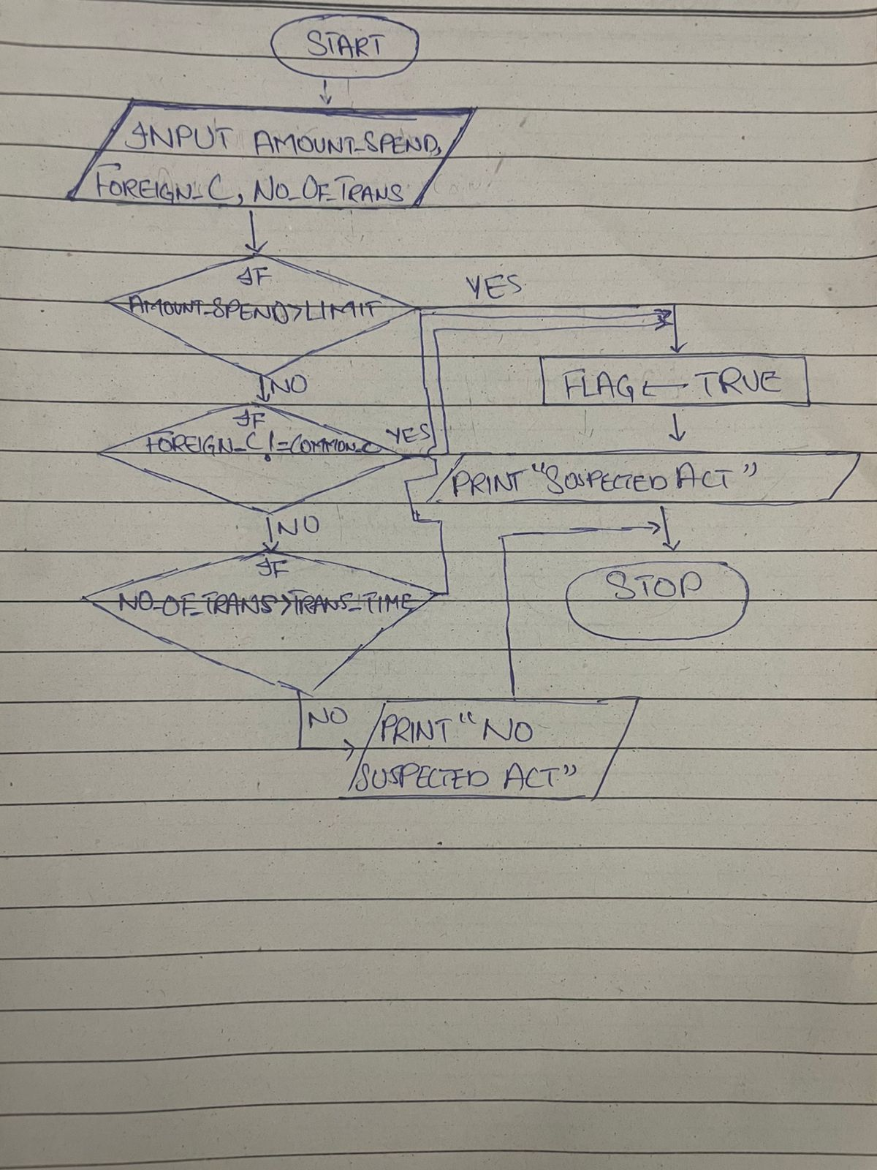

IPO:

INPUT | PROCESSING | MODULE | OUTPUT
CUSTOMER_ID  AMOUNT_SPEND  FOREIGN_COUNTRY  NO_OF_TRANSACTIONS | - Input Customer ID, Amount Spend, Foreign Country, Number of Transactions.  - Check if Amount spend exceeds amount limit.  - Check if the foreign country is different than common country.  - Check if number of transactions exceeds transaction count per hour.  - If any flag true mark suspicious.  - Print “Transaction Suspicious”.  - End. | - INPUT  - CALC  - CALC  - CALC  - CALC  - PRINT  - END | Declare Suspicious Activity, inform Risk Management System based on the conditions.

ALGORITHM:

STEP 1: START
STEP 2: INPUT CUTOMER_ID, AMOUNT_SPEND
STEP 3: Compare IF, AMOUNT_SPEND>AMOUNT_LIMIT, FLAG = “TRUE”
STEP 4: INPUT FOREIGN_COUNTRY
STEP 5: Compare IF, FOREIGN_COUNTRY != COMMON_COUNTRY, FLAG = “TRUE”
STEP 6: INPUT TRANSACTION_COUNT_TIME
STEP 7: Compare IF, NO_OF_TRANSACTIONS > TRANSACTION_COUNT_TIME, FLAG = “TRUE”
STEP 8: IF, FLAG = “TRUE”, PRINT “Suspicious Activity Found!!!”, ELSE, PRINT “No Suspicious Activity Found!!!”
STEP 9: STOP
PSEUDOCODE:
START
INPUT CUSTOMER_ID
INPUT AMOUNT_SPEND
INPUT FOREIGN_COUNTRY
INPUT NO_OF_TRANSACTIONS
SET AMOUNT_LIMIT = 50000
SET TRANSACTION_COUNT_HOUR = 3
DECLARE FLAG = FALSE
IF AMOUNT_SPEND > DAILY_LIMIT THEN
FLAG = TRUE
ENDIF
IF (FOREIGN_COUNTRY != COMMON_COUNTRY1)
AND (FOREIGN_COUNTRY != COMMON_COUNTY 2)
AND (FOREIGN_COUNTRY != COMMON_COUNTRY3) THEN
FLAG = TRUE
ENDIF
IF (NO_OF_TRANSACTIONS > TRANSACTION_COUNT_TIME) THEN
FLAG = TRUE
ENDIF
IF FALG = TRUE THEN
PRINT “Suspicious Activity Found”
ELSE
PRINT “No Suspicious Activity Found”
ENDIF
STOP

C CODE:
#include <stdio.h>
#include <stdbool.h>

int main(){
int customerId;
int amountSpent;
int amountLimit = 50000;
int foreignCountry;
int noOfTransactions;
int transactionCountHour = 3;
bool flag = false;

printf("------/-----\n");
printf("Enter your ID:");
scanf("%d", &customerId);
printf("Enter the amount you have spent:");
scanf("%d", &amountSpent);
if(amountSpent > amountLimit){
flag = true;
}
printf("Enter the foreign country:(use 1 for Pakistan, 2 for UAE and 3 for others)");
scanf("%d", &foreignCountry);
if(foreignCountry >= 3){
flag = true;
}
printf("Enter the number of transcations in time:");
scanf("%d", &noOfTransactions);
if(noOfTransactions > transactionCountHour){
flag = true;
}
if(flag){
printf("A Suspected Activity!!!");
}
else{
printf("No Suspected Activity Found!!!");
}

return 0;

}

QUESTION 2
GIVEN DATA | REQUIRED RESULTS
- X-Axis  - Y-Axis | - Quadrants
PROCESSING REQUIRED | ALTERNATIVE SOLUTIONS
- Check IF(x > 0 && y >0)  - Check IF(x < 0 && y > 0)  - Check IF(x < 0 && y < 0)  - Check IF(x > 0 && y < 0)  - THEN PRINT “Quadrant” | - Define all the values to be compared as constants in the program.  - Take input of all the values to be evaluated.  - Use comparing statements in conditional statements.

PAC:

IPO:

INPUT | PROCESSING | MODULE | OUTPUT
X_AXIS  Y_AXIS | - Input X_AXIS value  - Input Y_AXIS value  - Check if coordinates lie on first quadrant  - Check if coordinate lie on second quadrant  - Check if coordinates lie on third quadrant  - Check if coordinates lie on forth quadrant  - Print Quadrant  - End | - INPUT  - INPUT  - CALC  - CALC  - CALC  - CALC  - PRINT  - END | Print “Quadrants of coordinate axis”.

ALGORITHM:
STEP 1: START
STEP2: Take INPUT, X
STEP3: Take INPUT, Y

STEP4: IF X > 0 AND Y > 0 THEN

STEP5: PRINT “QUADRANT I”

STEP6: IF X < 0 AND Y > 0 THEN

STEP7: PRINT “QUADRANT II”

STEP4: IF X <0 AND Y < 0 THEN

STEP5: PRINT “QUADRANT III”

STEP6: IF X > 0 AND Y < 0 THEN

STEP7: PRINT “QUADRANT IV”

STEP8: STOP

PSEUDOCODE:

START
INPUT X
INTPUT Y
IF (X > 0 AND Y > 0) THEN
PRINT “(X, Y) lies on Quadrant I”
ELSE IF (X < 0 AND Y > 0) THEN
PRINT “(X, Y) lies on Quadrant II”
IF (X < 0 AND Y < 0) THEN
PRINT “(X, Y) lies on Quadrant III”
IF (X > 0 AND Y < 0) THEN
PRINT “(X, Y) lies on Quadrant IV”
ENDIF
STOP

FLOWCHART: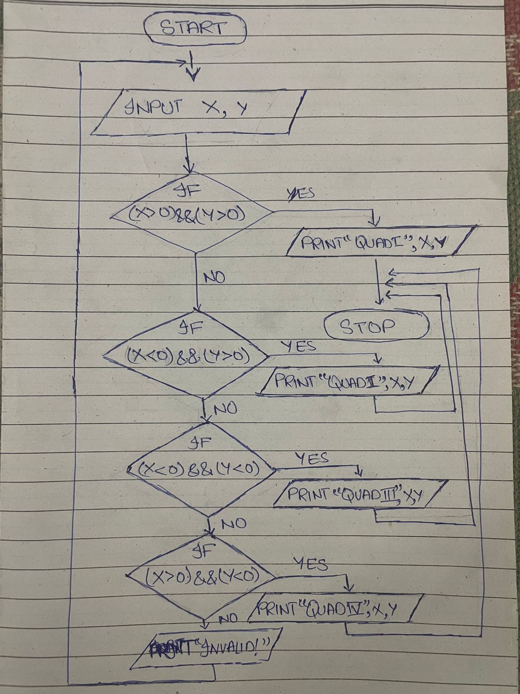

CODE:

#include <stdio.h>
#include <stdbool.h>

int main(){
int x;
int y;

printf("---/---\n");
printf("Enter the point on x-axis:");
scanf("%d", &x);
printf("Enter the point on y-axis:");
scanf("%d", &y);
if((x > 0) && (y > 0)){
printf("(%d, %d) lies on Quadrant-I", x, y);
}
else if((x < 0) && (y > 0)){
printf("(%d, %d) lies on Quadrant-II", x, y);
}
else if((x < 0) && (y < 0)){
printf("(%d, %d) lies on Quadrant-III", x, y);
}
else if((x > 0) && (y < 0)){
printf("(%d, %d) lies on Quadrant-IV", x, y);
}
else{
printf("Point doesn't lies on a quadrant!!");
}

return 0;
}

QUESTION 3

GIVEN DATA | REQUIRED RESULTS
- AGE  - EYE_EXAM  - WRITTEN_TEST  - DRIVING_TEST  - MD_CERTIFICATE | - ELIGIBALE FOR DRIVING OR NOT
PROCESSING REQUIRED | ALTERNATIVE SOLUTIONS
- Check if Age ≥ 18  - Eyesight Test: if Fail, suggest glasses, else continue  - Written Test: if Fail, retake required, else continue  - Driving Test: if Fail, not eligible, else continue  - If Age ≤ 60; eligible directly  - If Age > 60; check Medical Certificate:  - If Yes, Eligible.  - If No, Not Eligible. | - Define all the values to be compared as constants in the program.  - Take input of all the values to be evaluated.  - Use comparing statements in conditional statements.

PAC:

IPO:
INPUT | PROCESSING | MODULE | OUTPUT
AGE  EYE_EXAM  WRITTEN_TEST  DRIVING_TEST  MD_CERTIFICATE | 1)Input Age  2)Check if Age ≥ 18  3)Ask for eye sight test  4)Ask for written test  5)Ask for driving test  6)If Age ≤ 60 then make the user eligible directly.  7)If Age > 60 than ask for Medical Certificate:  If Yes, Eligible.  If No, Not Eligible.  8)END | 1)READ  2)CALC  3)READ  4)READ  5)READ  6)CALC  7)CALC  8)END | Display whether the applicant is eligible for license or not.

ALGORITHM:

STEP 1: START
STEP 2: READ AGE, DRIVING_TEST, WRITING_TEST, EYE_SIGHT
STEP 3: IF AGE < 18, PRINT “Age must be 18 or greater”
STEP 4: IF EYE_SIGHT == FALSE, PRINT “NEED MEDICAL TREATMENT”
STEP 5: IF WRITING_TEST == FALSE, PRINT “NEED TO PASS WRITING TEST”
STEP 6: IF DRIVING_TEST == FALSE, PRINT “NEED TO PASS DRIVING TEST”
STEP 7: IF AGE > 60 and condition is FALSE THEN, PRINT “CONGRATES, YOU ARE ELIGIBLE”
STEP 8: IF MEDICAL_CERTIFICATE == FALSE, PRINT “Sorry, you aren’t eligible”
STEP 9: STOP

PSEUDOCODE:

START
READ AGE, DRIVING_TEST, WRITING_TEST, EYE_SIGHT, MEDICAL_CERTIFICATE
DECLARE SIGHT_LIMIT
IF AGE < 18 THEN
PRINT “You must have to be 18 or older”
ENDIF
IF EYE_SIGHT < SIGHT_LIMIT THEN
PRINT “NEED MEDICAL TREATMENT”
ELSE IF WRITING_TEST == FALSE THEN
PRINT “NEED TO PASS WRITING TEST”
ELSE IF DRIVING_TEST == FALSE THEN
PRINT “NEED TO PASS WRITING TEST”
ELSE IF (AGE > 60) == FALSE THEN
PRINT “Congrats, you are eligible for license”
ELSE IF MEDICAL_CERTIFICATE THEN
PRINT “Congrats, you are eligible for license”
ELSE
PRINT “Sorry, you are not eligible”
ENDIF
STOP

FLOWCHART: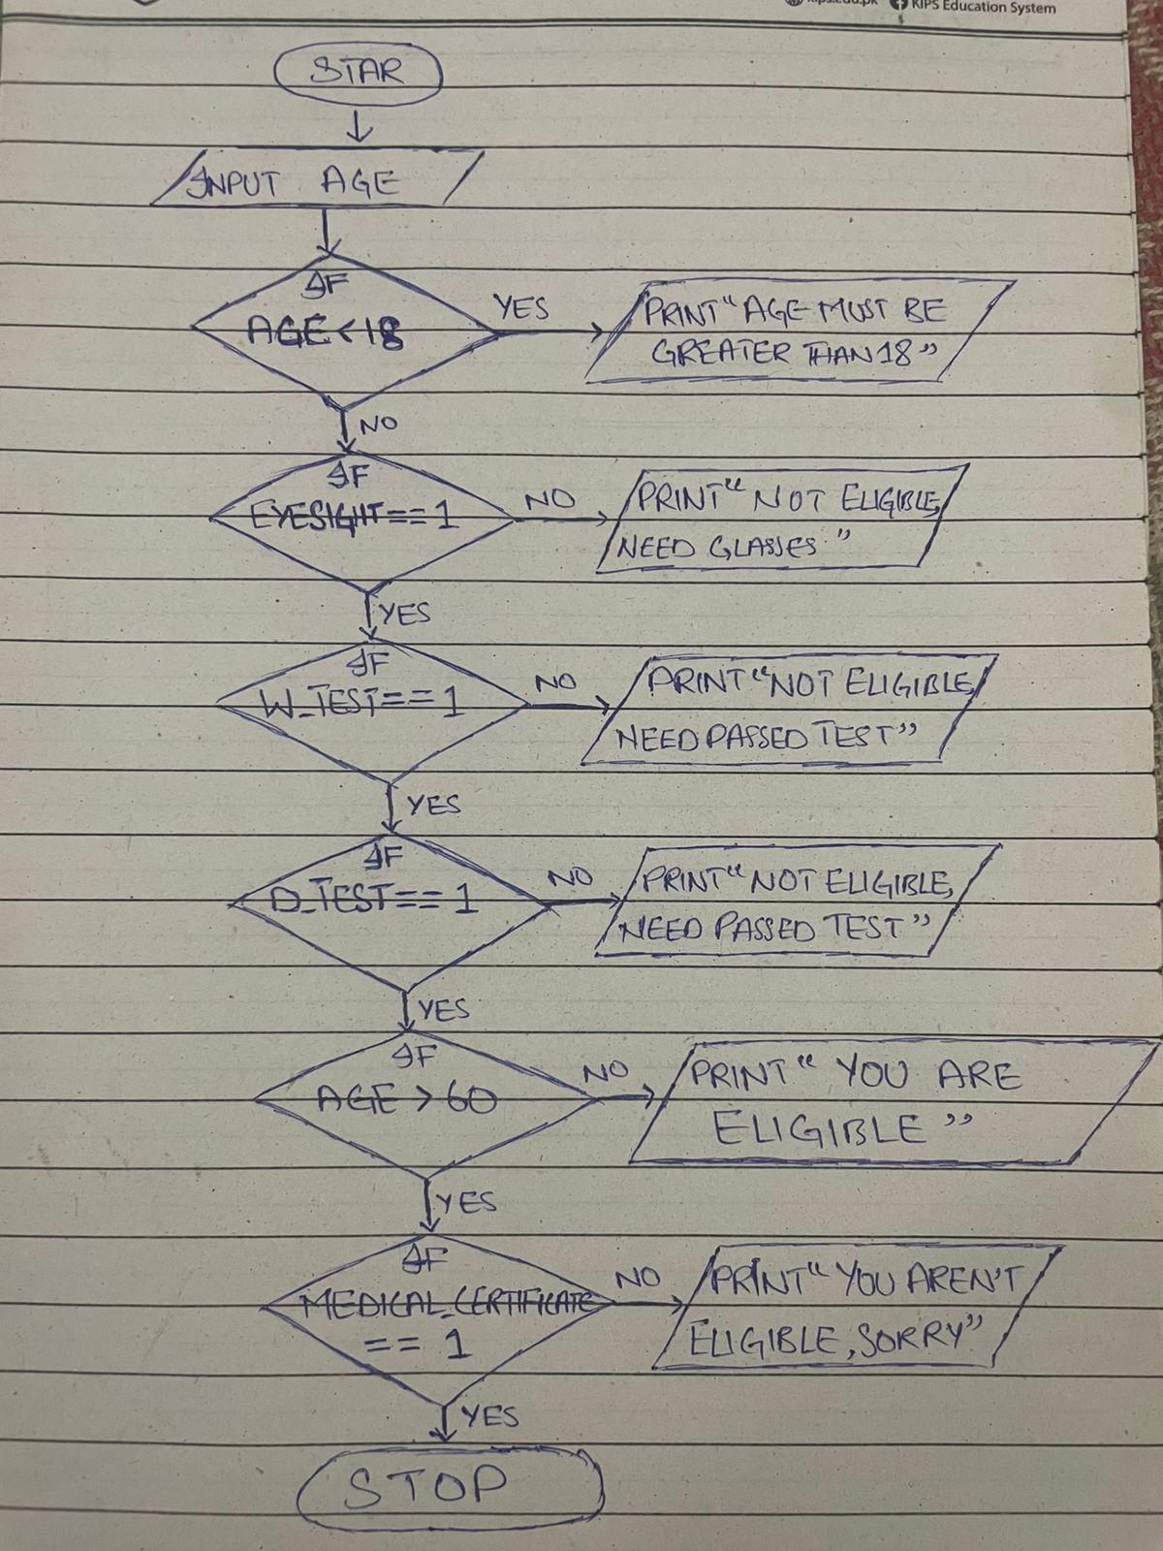

CODE:

#include <stdio.h>
#include <stdbool.h>

int main(){
int age;
int eyeExam;
int writtenTest;
int drivingTest;
int mdCertificate;

printf("--------/---------");
printf("Please enter your age:");
scanf("%d", &age);

if(age >= 18){
printf("Have you passed your eye exam (enter 1 for pass and 2 for fail):");
scanf("%d", &eyeExam);
if(eyeExam == 1){
printf("Have you passed your written test(enter 1 for pass and 2 for fail):");
scanf("%d", &writtenTest);
if(writtenTest == 1){
printf("Have you passed your driving test(enter 1 for pass and 2 for fail):");
scanf("%d", &drivingTest);
if(drivingTest == 1){
if(age <= 60){
printf("Congratulations! You are eligible for license");
}
else{
printf("Do you have a medical certificate?(enter 1 for true and 2 for false):");
scanf("%d", &mdCertificate);
if(mdCertificate == 1){
printf("Congratulaitons! You are eligible for license");
}
else{
printf("Sorry! You are not eligible for license");
}
}
}
else{
printf("You need to retake the driving test");
}
}
else{
printf("You need to retake the written test");
}
}
else{
printf("You need a prescription for glasses");
}

}
else{
printf("I am sorry, You are not eligible!");
}
return 0;
}

QUESTION 4
PAC:
GIVEN DATA | REQUIRED RESULTS
N1  N2  N3  N4  N5 | - CHECK FOR A FULL HOUSE
PROCESSING REQUIRED | ALTERNATIVE SOLUTIONS
Checking for card matching patterns:  (Cards N1,N3, N4 same AND cards N2,N5 same), (Cards N1,N4,N5 same AND cards N2,N3 same), (Cards N2,N3,N4 same AND cards N1,N5 same), (Cards N2,N4,N5 same AND cards N1,N3 same) or (Cards N3,N4,N5 same AND cards N1,N2 same)  If condition = TRUE, THEN  PRINT “FULL HOUSE”  ELSE PRINT “NO FULL HOUSE” | - Define all the values to be compared as constants in the program.  - Take input of all the values to be evaluated.  - Use threshold.  - Use basic statistics.

IPO:
INPUT | PROCESSING | MODULE | OUTPUT
N1  N2  N3  N4  N5 | 1)INPUT 5 card numbers N1, N2, N3, N4, N5  2)Check for (Cards N1,N3,N4 same AND cards N2,N5 same)  3)Check for (Cards N1,N4,N5 same AND cards N2,N3 same)  4)Check for (Cards N2,N3,N4 same AND cards N1,N5 same)  5)Check for (Cards N2,N4,N5 same AND cards N1,N3 same)  6)Check for (Cards N3,N4,N5 same AND cards N1,N2 same)  7)If any cases match PRINT “You have a full house”  8)END | 1)READ  2)CALC  3)CALC  4)CALC  5)CALC  6)CALC  7)PRINT  8)END | Check for a full house.

ALGORITHM:

STEP 1: START
STEP 2: READ n1, n2, n3, n4, n5
STEP 3: Check IF three cards same AND two cards are same AND three != two
STEP 4: Given condition TRUE THEN PRINT, “House Full”
STEP 5: Given condition FALSE THEN RPINT, “Not a Full House”
STEP 6: STOP

PSEUDOCODE:

START
READ: n1,n2,n3,n4,n5
IF ((n1==n2 && n2==n3 && n3!=n4 && n4==n5) ||
(n1==n2 && n2==n4 && n4!=n3 && n3==n5)||
(n1==n2 && n2==n5 && n5!=n4 && n4==n3)||
(n1==n3 && n3==n4 && n4!=n5 && n5==n2)||
(n1==n3 && n3==n5 && n5!=n4 && n4==n2)||
(n1==n4 && n4==n5 && n5!=n3 && n3==n2)||
(n2==n3 && n3==n4 && n4!=n5 && n5==n1)||
(n2==n3 && n3==n5 && n5!=n4 && n4==n1)||
(n2==n4 && n4==n5 && n5!=n3 && n3==n1)||
(n3==n4 && n4==n5 && n5!=n2 && n2==n1)) THEN
DISPLAY “The hand (n1,n2,n3,n4,n5) is a full house”
ELSE
DISPLAY “The hand (n1,n2,n3,n4,n5) is not a full house”
END

FLOWCHART:
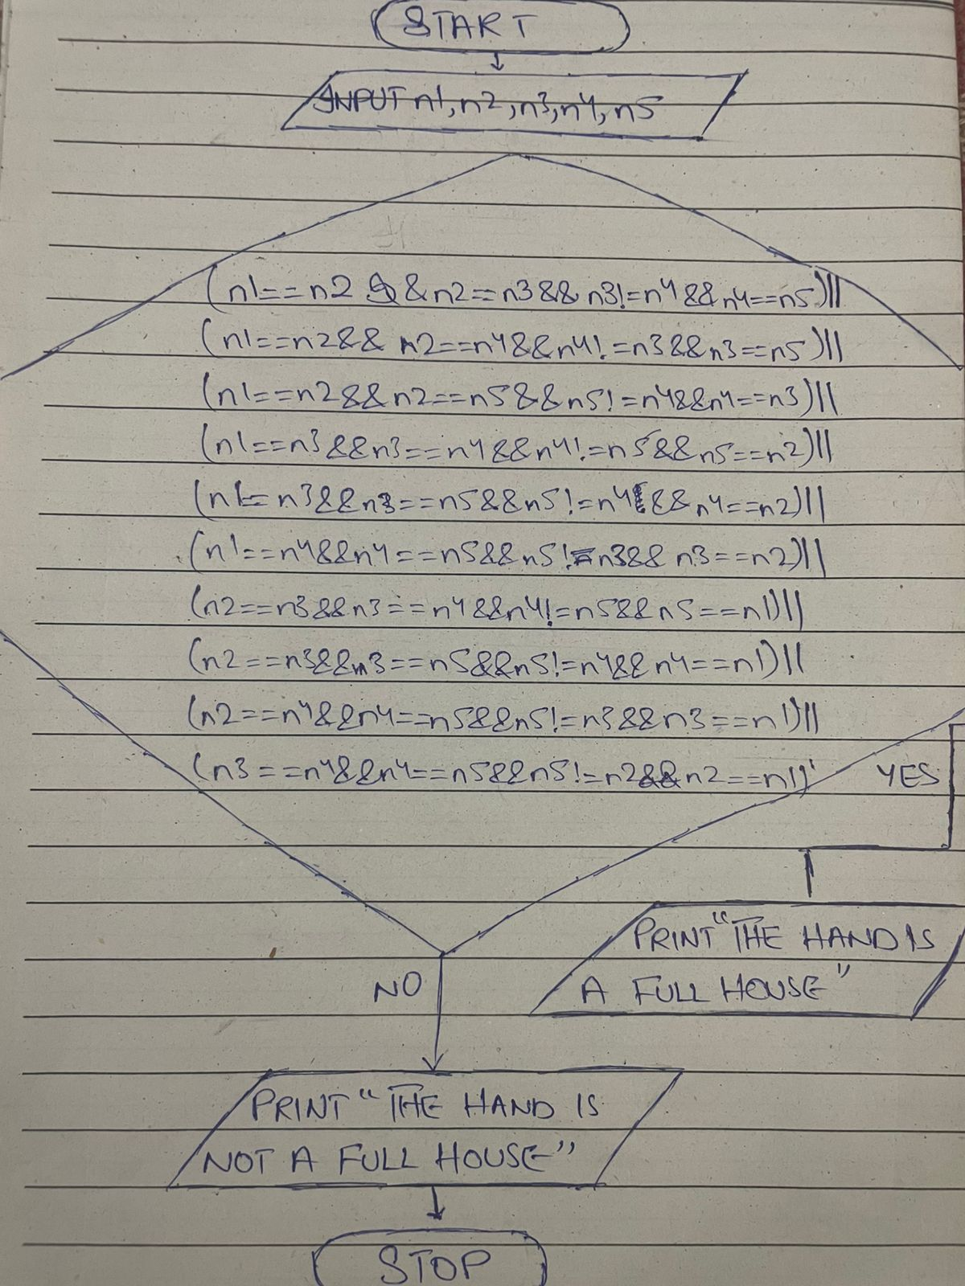

CODE:

#include <stdio.h>

int main(){
int n1,n2,n3,n4,n5;
printf("Here: \n- 1 represents Ace, \n- 2-10 represent cards numbered 2 through 10, \n- 11 represents Jack, \n- 12 represents Queen, \n- 13 represents King.");
printf("\nEnter your Poker Hand in the range 1...13 : ");
scanf("%d %d %d %d %d", &n1, &n2, &n3, &n4, &n5);

if((n1==n2 && n2==n3 && n3!=n4 && n4==n5) ||
(n1==n2 && n2==n4 && n4!=n3 && n3==n5)||
(n1==n2 && n2==n5 && n5!=n4 && n4==n3)||
(n1==n3 && n3==n4 && n4!=n5 && n5==n2)||
(n1==n3 && n3==n5 && n5!=n4 && n4==n2)||
(n1==n4 && n4==n5 && n5!=n3 && n3==n2)||
(n2==n3 && n3==n4 && n4!=n5 && n5==n1)||
(n2==n3 && n3==n5 && n5!=n4 && n4==n1)||
(n2==n4 && n4==n5 && n5!=n3 && n3==n1)||
(n3==n4 && n4==n5 && n5!=n2 && n2==n1)){
printf("The hand (%d, %d, %d, %d, %d) is a full house.", n1, n2, n3, n4, n5);
}
else{
printf("The hand (%d, %d, %d, %d, %d) is not a full house.", n1, n2, n3, n4, n5);
}
return 0;
}

QUESTION 5

CODE:

#include <stdio.h>
#include <stdbool.h>

int main(){
int condition = 1;
int n;
int count0 = 0, count1 = 0, count2 = 0, count3 = 0, count4 = 0, count5 = 0, count6 = 0, count7= 0, count8 = 0, count9 = 0;
bool flag = false;
printf("Do you want to enter one digit number :(use 1 for YES and 0 for NO)");
scanf("%d", &condition);
while(condition){

printf("Enter a one digit number from 1 to 9:");
scanf("%d", &n);
if((n >= 0)&&(n<=9)){

switch(n){
case 0: count0++;
break;
case 1: count1++;
break;
case 2: count2++;
break;
case 3: count3++;
break;
case 4: count4++;
break;
case 5: count5++;
break;
case 6: count6++;
break;
case 7: count7++;
break;
case 8: count8++;
break;
case 9: count9++;
break;
}
flag = true;
}
else{
break;
}
}

if(flag){
printf("----/ Vlaues Entered With Number Of Repetation! /----\n");
printf("NUMBER \t \t Number Of Occurance\n");
if (count0 > 0) printf("0\t%d\n", count0);
if (count1 > 0) printf("1\t%d\n", count1);
if (count2 > 0) printf("2\t%d\n", count2);
if (count3 > 0) printf("3\t%d\n", count3);
if (count4 > 0) printf("4\t%d\n", count4);
if (count5 > 0) printf("5\t%d\n", count5);
if (count6 > 0) printf("6\t%d\n", count6);
if (count7 > 0) printf("7\t%d\n", count7);
if (count8 > 0) printf("8\t%d\n", count8);
if (count9 > 0) printf("9\t%d\n", count9);
}
return 0;

}

QUESTION 6
DRY RUN:
a) i = 3, j = 5 and k = 7
ANS = 5,5,7
b) i = 3, j = 7 and k = 5
ANS= 3,7,5
c) i = 5, j = 3 and k = 7
ANS= 5,7,7
d) i = 5, j is 7 and k = 3
ANS= 5,7,3
e) i = 7, j = 3 and k = 5
ANS= 7,5,5
f) i = 7, j = 5 and k = 3
ANS= 7,3,3

QUESTION 7
#include <stdio.h>
#include <stdbool.h>

int main(){
int value;

printf("Please enter a value in the range 1...7: ");
scanf("%d", &value);

// Translate number into corresponding Weekday
if (value == 1) {
printf("You entered a Monday\n");
} else if (value == 2) {
printf("You entered a Tuesday\n");
} else if (value == 3) {
printf("You entered a Wednesday\n");
} else if (value == 4) {
printf("You entered a Thrusday\n");
} else if (value == 5) {
printf("You entered a Friday\n");
}
else if (value == 6) {
printf("You entered a Saturday\n");
} else if (value == 7) {
printf("You entered a Sunday\n");
} else {
printf("You entered a value out of range\n");
}

return 0;

}

